**FOURIER TRANSFORM**

**AMPLITUDE, MAGNITUDE AND PHASE VISUALIZATION**

Student: Vilceanu Dumitru, MCE, 2013

The **Fourier transform**, named after [Joseph Fourier](http://en.wikipedia.org/wiki/Joseph_Fourier), is a mathematical [transformation](http://en.wikipedia.org/wiki/Transformation_(function)) employed to transform signals between [time](http://en.wikipedia.org/wiki/Time_domain) (or spatial) domain and [frequency domain](http://en.wikipedia.org/wiki/Frequency_domain), which has many applications in [physics](http://en.wikipedia.org/wiki/Physics) and [engineering](http://en.wikipedia.org/wiki/Engineering) [1]. The Fourier Transform is an important image processing tool which is used to decompose an image into its sine and cosine components. The output of the transformation represents the image in the Fourier or [frequency domain](http://homepages.inf.ed.ac.uk/rbf/HIPR2/freqdom.htm), while the input image is the [spatial domain](http://homepages.inf.ed.ac.uk/rbf/HIPR2/spatdom.htm) equivalent. In the Fourier domain image, each point represents a particular frequency contained in the spatial domain image [2].

The Fourier Transform is used in a wide range of applications, such as image analysis, image filtering, image reconstruction and image compression.

To apply the Fourier transform to a image we will use the Discrete Fourier Transform (DTF). The number of frequencies corresponds to the number of pixels in the spatial domain image, therefore the image in the spatial and Fourier domain are of the same size.

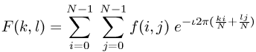For a square image of size N×N, the two-dimensional DFT is given by:

where *f(a,b)* is the image in the spatial domain and the exponential term is the basis function corresponding to each point *F(k,l)* in the Fourier space. The equation can be interpreted as: the value of each point *F(k,l)* is obtained by multiplying the spatial image with the corresponding base function and summing the result.

The basic functions are sine and cosine waves with increasing frequencies, *i.e.* *F(0,0)* represents the DC-component of the image which corresponds to the average brightness and *F(N-1,N-1)* represents the highest frequency.

In a similar way, the Fourier image can be re-transformed to the spatial domain. http://homepages.inf.ed.ac.uk/rbf/HIPR2/mote.gifThe inverse Fourier transform is given by:

Eqn:eqnfour2

Note the Eqn:oneovern2 normalization term in the inverse transformation. This normalization is sometimes applied to the forward transform instead of the inverse transform, but it should not be used for both [2].

Eqn:eqnfour3To obtain the result for the above equations, a double sum has to be calculated for each image point. However, because the Fourier Transform is *separable*, it can be written as

where

Eqn:eqnfour4

Using these two formulas, the spatial domain image is first transformed into an intermediate image using *N* one-dimensional Fourier Transforms. This intermediate image is then transformed into the final image, again using *N* one-dimensional Fourier Transforms. Expressing the two-dimensional Fourier Transform in terms of a series of *2N* one-dimensional transforms decreases the number of required computations.

http://homepages.inf.ed.ac.uk/rbf/HIPR2/mote.gifEven with these computational savings, the ordinary one-dimensional DFT has **N2** complexity. This can be reduced to **N log 2N** if we employ the *Fast Fourier Transform* (FFT) to compute the one-dimensional DFTs. This is a significant improvement, in particular for large images. There are various forms of the FFT and most of them restrict the size of the input image that may be transformed, often to **N = 2n** where *n* is an integer. The mathematical details are well described in the literature.

The Fourier Transform produces a complex number valued output image which can be displayed with two images, either with the real and imaginary part or with magnitude and phase. In image processing, often only the magnitude of the Fourier Transform is displayed, as it contains most of the information of the geometric structure of the spatial domain image. However, if we want to re-transform the Fourier image into the correct spatial domain after some processing in the frequency domain, we must make sure to preserve both magnitude and phase of the Fourier image.

The Fourier domain image has a much greater range than the image in the spatial domain. Hence, to be sufficiently accurate, its values are usually calculated and stored in float values.

Recall that the definition of the Fourier Transform is:

F(u,v) = SUM{ f(x,y)*exp(-j*2*pi*(u*x+v*y)/N) }

and

f(x,y) = SUM{ F(u,v)*exp(+j*2*pi*(u*x+v*y)/N) }

where u = 0,1,2,...,N-1 and v = 0,1,2,...,N-1

x = 0,1,2,...,N-1 and y = 0,1,2,...,N-1

and SUM means double summation over proper

x,y or u,v ranges

Note that f(x,y) is the image and is REAL, but F(u,v) (abbreviate as F) is the FT and is, in general, COMPLEX. Generally, F is represented by its MAGNITUDE and PHASE rather that its REAL and IMAGINARY parts, where:

**MAGNITUDE(F) = SQRT( REAL(F)^2+IMAGINARY(F)^2 )**

**PHASE(F) = ATAN( IMAGINARY(F)/REAL(F) )**

Briefly, the MAGNITUDE tells "how much" of a certain frequency component is present and the PHASE tells "where" the frequency component is in the image. To illustrate this consider the following [3].

|  |
| --- |
| http://www.cs.unm.edu/~brayer/vision/phase.gif |

Note that the FT images we look at are just the MAGNITUDE images. The images displayed are horizontal cosines of 8 cycles, differing only by the fact that one is shifted laterally from the other by 1/2 cycle (or by PI in phase). Note that both have the same FT MAGNITUDE image. The PHASE images would be different, of course. Nevertheless, it is wise to remember that when one looks at a common FT image and thinks about "high" frequency power and "low" frequency power, this is only the MAGNITUDE part of the FT.

By the way, you may have heard of the FFT and wondered if was different from the FT. FFT stands for "Fast" Fourier Transform and is simply a fast algorithm for computing the Fourier Transform.

Usually the DFT is computed by a truly revolutionary algorithm known as the Fast Fourier Transform or FFT. The FFT was discovered by Gauss in 1805, but most people attribute its modern incarnation to James W. Cooley and John W. Tukey in 1965[3]. The key advantage of the FFT over the DFT is that the operational complexity decreases from O(N2) for a DFT to O(Nlog (N)) for the FFT. Modern implementations of the FFT (such as FFTW) allow O(Nlog2(N)) complexity for any value of N, not just those that are powers of two or the products of only small primes [4].

Example:

The Fourier Transform is used if we want to access the geometric characteristics of a spatial domain image. Because the image in the Fourier domain is decomposed into its sinusoidal components, it is easy to examine or process certain frequencies of the image, thus influencing the geometric structure in the spatial domain [2].

In most implementations the Fourier image is shifted in such a way that the DC-value (*i.e.* the image mean) *F(0,0)* is displayed in the center of the image. The further away from the center an image point is, the higher is its corresponding frequency.

We start off by applying the Fourier Transform of

The magnitude calculated from the complex result is shown in

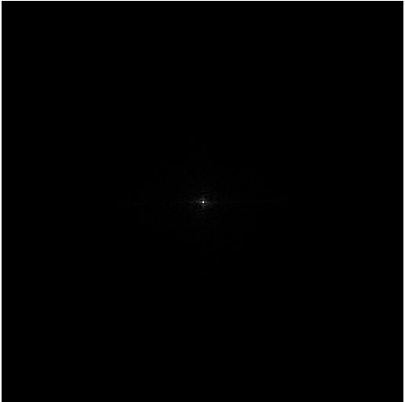

[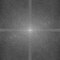](http://homepages.inf.ed.ac.uk/rbf/HIPR2/images/cln1fur2.gif)We can see that the DC-value is by far the largest component of the image. However, the dynamic range of the Fourier coefficients (*i.e.* the intensity values in the Fourier image) is too large to be displayed on the screen, therefore all other values appear as black. If we apply a [logarithmic transformation](http://homepages.inf.ed.ac.uk/rbf/HIPR2/pixlog.htm) to the image we obtain

The result shows that the image contains components of all frequencies, but that their magnitude gets smaller for higher frequencies. Hence, low frequencies contain more image information than the higher ones. The transform image also tells us that there are two dominating directions in the Fourier image, one passing vertically and one horizontally through the center. These originate from the regular patterns in the background of the original image.

[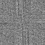](http://homepages.inf.ed.ac.uk/rbf/HIPR2/images/cln1fur3.gif)The phase of the Fourier transform of the same image is shown in

**Conclusions:**

- The Fourier Transform is a powerful way of viewing waveforms. A waveform is something that can describe virtually everything in the world - a function of time, space or some other variable.

- Fourier Transform is used for both signal processing and image processing

- Examples of reasons of using Fourier Transform for image processing:

* Enhancement: improving or changing a picture in some way.
* Compression: reducing the storage required, usually to customize on storage or speed up transmission.
* Recognition: automatically recognize objects, like faces or objects. Using the proper filter, this case is used in navigation, scanning luggage at airports or military industry.

**Bibliography:**

1. <http://en.wikipedia.org/wiki/Fourier_transform>
2. <http://homepages.inf.ed.ac.uk/rbf/HIPR2/fourier.htm>
3. <http://www.cs.unm.edu/~brayer/vision/fourier.html>
4. <http://www.cv.nrao.edu/course/astr534/FourierTransforms.html>
5. <http://en.wikipedia.org/wiki/Cooley%E2%80%93Tukey_FFT_algorithm>